Learning Together

Welcome
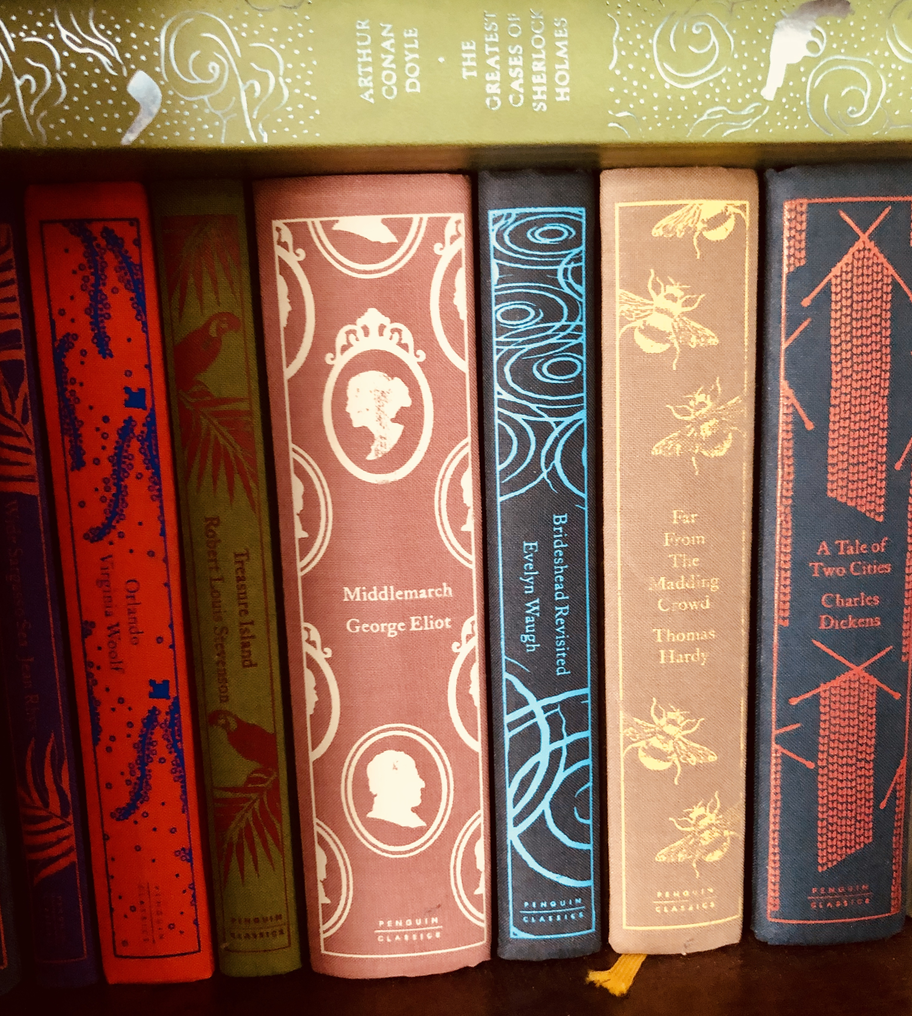
Firstly, welcome to the first termly Learning Together – our King’s Lynn Academy learning journal. Our aim is simple – to promote learning for all of us. Whatever the stage in our career, we believe that all of us are on a learning journey, and this journal is a part of that. Here you will find up to date theory and pedagogy, as well as support on some of our key learning priorities moving forward. There are also links to some further reading should you wish to explore further.

Words... Words… Words…
What was the biggest event in the history of all mankind? The biggest bang since the first Big Bang? The Agricultural Revolution? Perhaps the Industrial Revolution? Or maybe we live in it now – the age of computers – the Internet Revolution?
Each of these cataclysmic events heralded huge change but all were dependent on one other revolution - when our ancestors’ guttural grunts and wild hand signals morphed into what we know as language. Recognisable humans stomped the earth 200,000 years ago, but it wasn’t until later, perhaps some 60-70,000 years ago, that this Big Bang of the brain appeared and spoken language began to emerge. This was perhaps the biggest event in the history of mankind so far – a “Cognitive explosion”, where reason, thought, logic could be conveyed, where emotion and the nuances of meanings could be communicated. Words moved far beyond the simple labelling of things in our world; tenses evolved to share our present experiences, to remember our past, and to give meanings to our lives as we hoped for the future. Humans learned language by mimicry and listened to stories passed from generation to generation – often making sense of their world. And it was only later, some 55,000 years later, that the earliest writing appeared, offering more control, more thought, and more experience of the world. Like a bird’s impulse to fly, is mankind’s impulse to speak, but writing…writing needs to be taught, just like its counterpart of reading. As for vocabulary, we haven’t evolved from our ancestors’ instincts to listen and copy, and therefore learn new words.
The teaching of language is the first responsibility of all teachers. Without language – the right words – there is limited thinking. Without being able to express learning, an idea is lost in a fog, unclear and vague.
At KLA an unremitting focus on teaching language is one of our priorities; the gap between those who are proficient with language, and those who are not, affects more than just academic success, but an individual’s very life chances. And it’s a gap that is formed early on…
“From birth to 48 months, parents in professional families spoke 32 million more words to their children than parents in welfare families, and this talk gap between the ages of 0 and 3 year- not parent education, socio-economic status or race – explains the vocabulary and language gap at age 3 and the reading and achieved entry gap aged 10.” (Closing the Vocabulary gap – Alex Quigley)
Our role then is to teach this language that makes the difference, not only to help our children get the GCSE results that they deserve, but to experience and communicate a richer life.
Beck Tiers of Vocabulary
At KLA we challenge students about language, and one of our shared models for doing this is Beck’s Three Tiers of Vocabulary. Isabel Beck’s publication “Bringing Words to Life” suggests a three-tier hierarchical structure for language, ranging from the everyday language we use, through more academic language, to specialised terms.
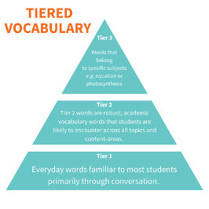
Back in March, we looked at this model together, and colleagues spent time considering the vocabulary of their subject. We need to be encouraging students to move beyond the comfort of the most basic words (Tier One) and instead use academic vocabulary (Tier Two) in their responses. Where appropriate they move further, employing the academic vocabulary necessary to discuss their learning in that subject in a meaningful way. Colleagues are encouraged to refer explicitly to tiers of vocabulary in their dialogue with students, being explicit about what type of words they expect. In Maths, “taking away” becomes subtraction, “Timesing” becomes multiplication, and equations are something that require balancing as opposed to getting an equal value by “chucking things over the fence”!!!! We need to model this precision when we talk and be aware that the children will be no different from our ancestors from thousands of years ago – learning through mimicry!
Frayer’s Model
How many times have we glossed over difficult words with no explanation? Or worse still, tried to make academic language accessible by “dumbing down” definitions? Picture the following lesson on A Christmas Carol…
“Sir, what does misanthropic mean?”
“It’s, sort of like, being nasty.”
Misanthropic doesn’t mean “sort of” anything! It means having or showing a dislike of others. It’s being unsociable, even anti-social. It’s a word that has the connotations of insult. It means much, much more than “being nasty”! And if we stop and look harder, we can see the prefix (or start of the word) has similarities with other words than mean something “ill” or negative. We don’t want our students to be mistaken by our misteaching of this miserable word. Still further we might look at the route – “anthropoid” and its meaning of being human, before talking about the philanthropic work of, say, Bill Gates.
More on this another time…but for now we must be agreed that using the correct words means students can think more precisely. And understanding words means that students need more than simple definitions. They need to understand the definition of the word, the characteristics of the word (its etymology), words that mean the same (synonyms) or different (antonyms), as well as putting the word into a workable sentence. The more the student feels able to play with the word, the more they know it and can use it. It then falls into longer term memory, reducing the cognitive load.
A brilliant model to teach vocabulary is the Frayer’s model – and it is our model of choice here at KLA.
Words are to be celebrated, enjoyed, considered, broken apart, built back up, quizzed and puzzled over. We should deliberately stop – and think – abut the words that we use. And we should model this to our students. The point of Frayer’s model is it provides a brilliant structure to do this in the form of a grid that we can fill in.
So, what goes in each box?
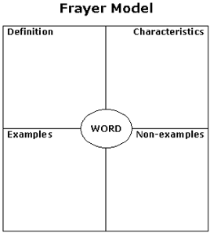
Definition – what does the word mean?
Characteristics – What features of the word can you spot – prefixes/ suffixes
Non- examples – What is this word not? What is the opposite of this word?
Examples – Can you put this in a workable sentence?

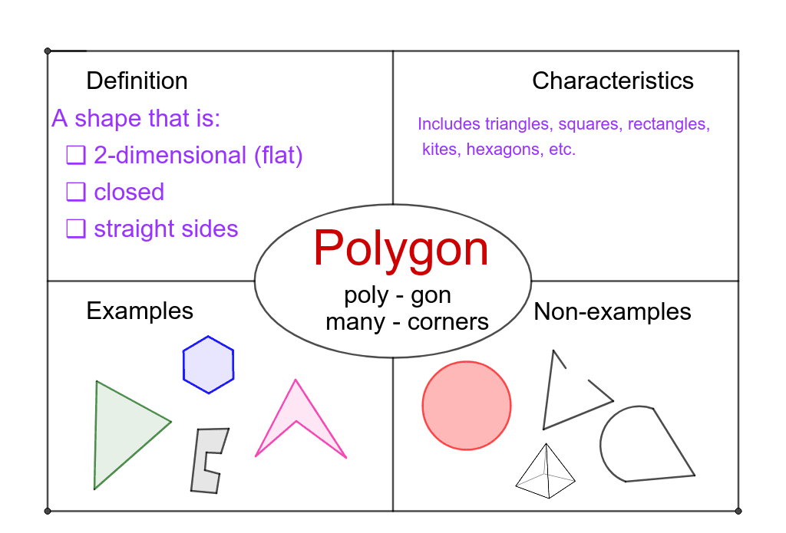
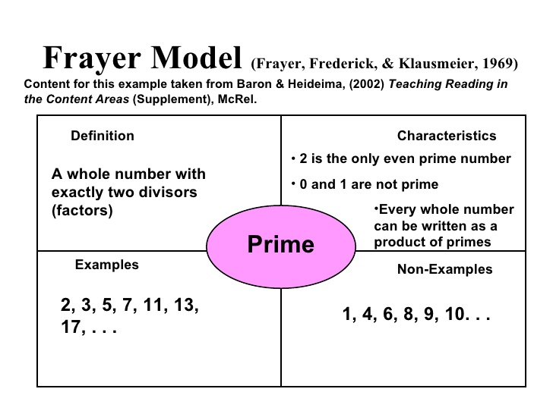
The joy of this approach is that you can adapt it to suit your purpose. Take a look at the examples below -

Making sure that we slow down, and spend time looking at words and their meanings, will of course reap huge rewards in the future. As students become familiar with words, they feel more confident using them. As students use words, their thinking will deepen, and their conceptual understanding will grow stronger. Language is all of our entitlement. We wrestle with the words until we control them. They don’t control us.
The Real Challenge - “We don’t need no education/ We don’t need no thought control.”
It’s 1979. At the end of a cold January, public sector workers unanimously decide to go on strike – the biggest since 1926, furious at the cap on their wages. Class divides are keenly felt, Eton Rifles is on the radio and Paul Weller snarls – “What chance have you got against a tie and a crest?” Another huge hit from this year is Pink Floyd’s Another Brick in the wall, with a choir of children chanting like robots. “We don’t need no education” which is seen as some kind of “thought control.”
It’s easy to look back and criticise what’s gone before. But what days of contradiction these seem now. Corporal punishment is in – the National curriculum – well that doesn’t even exist. According to education historians, the lack of language teaching was a humanist concept, self-expression reigned supreme, and though it would be wrong to suggest that “words were never taught”, they were not explicitly so. The chanting choir’s dulcet tone, and the double negative in the phrase – “we don’t need no education” implies the opposite – we do. The real thought control is when we can’t think the thoughts, because we don’t have the words. What’s more likely to make us another brick in the wall is if we can’t communicate, argue and even think properly because we don’t have the words. Paul Weller is right – what chance have you got against the tie and the crest of those that have been taught how to communicate?
If we learn spoken language by mimicry, and the language, the very words we hear, are limited - then we are sunk. Teachers need to model the words, the speaking that we expect. There is a type of language we use – that many of us have been successful in – that has unlocked the academic door and led to success. It is our responsibility to make sure that we explicitly teach this “code” to everyone. Everyone. Of course, some of our students will already be well on their way; but the warnings and studies are stark. Researchers have established the link between orally tested vocabulary at the end of the first year at school as a significant predictor of reading comprehension 10 years later. Put a different way, when you present a text to a student (any text) it will not be understood unless students know 95% of the words (Dan Willingham). If students are to get on and do well both at school and later in life, they need to be taught these words – using, for example, Becks and Frayer. Without them, there will be little true social mobility.
Challenging ourselves and our students in the language we use is vital. In our explanations and our feedback, we need to be precise, modelling what we expect. We should speak in clear full sentences and insist on the same in our students’ answers. This is academic discourse and it’s the entitlement of our students.
To not teach vocabulary, to not insist on high quality thinking, is real “thought control”.

Further reading –
Closing the Vocabulary Gap – Alex Quigley
The English Patient English Grammar and teaching in the twentieth century - Richard Hudson and John Walmsley

We are the "word-rich" and it’s up to us to help empower the "word-poor"…'
…and forcing those who don’t make the grade at GCSE English to endlessly retake it at college is not the way to go about it, writes the ASCL general secretary

Geoff Barton
16th November 2017

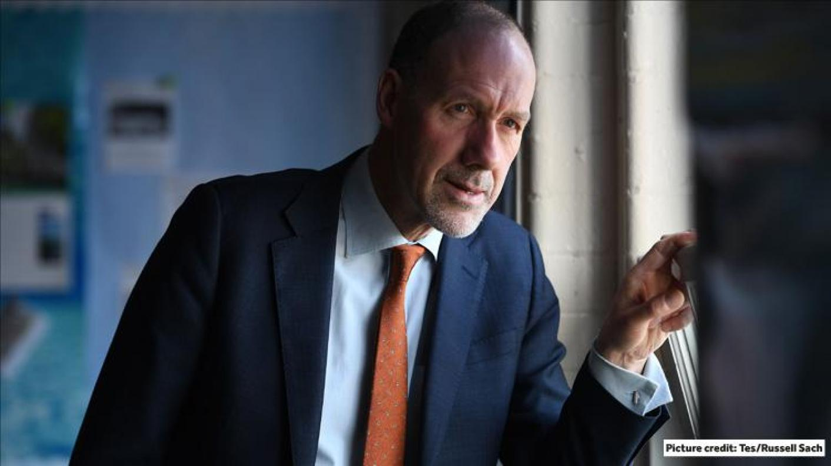

This is an article about language, about two broad groups of people who use it. As a shorthand, let’s call them the word-rich and the word-poor.
First: the word rich. This is you and me and people like us. It’s about those who – apparently effortlessly – can see inky words on a page or screen and decode them to make meaning, to see pictures, to understand ideas, and to enjoy stories. We routinely use vocabulary in both our speech and writing to express ourselves with precision and clarity.
We are the word-rich, and even the least confident of us will have ways of concealing our occasional linguistic anxieties. If there’s a word we’re uncertain about how to spell, such as "accommodation" or "fulfil", we’ll have a memory device, a mnemonic, to help us, or we’ll look it up, or we’ll simply substitute a different word with a similar meaning.
When we write we’ll avoid repetition of the same word because we learned that the repetition of the same word leads to clunky writing that is clunky because of the repetition of the same word. We’ll avoid doing so.

Language, culture and upbringing
As the word-rich, we’ll be able to read a book or article on a subject that’s familiar to us and scan it quickly, expertly, comparing what we’re reading now with our prior knowledge, simultaneously making decisions about what’s familiar, what’s novel, what’s true, what’s false.
You get the idea. We the word-rich will have habits of reading and writing and speaking and listening. We’ll have an idiolect – a personal repertoire of verbal mannerisms – that have accrued over the years and which help in part to define the people we are.
We’ll use language ourselves and be users of other people’s language. The result will be a self-confidence in being human, in being able both to interpret and express a view of the world and our relationship to it.
None of this is about intelligence. It’s about language, and culture, and upbringing, and power.
That’s us.
Then there’s the word-poor. This is the child who doesn’t hear conversations much at home, who doesn’t get read to, for whom books aren’t a feature of the family landscape, and for whom the world of primary and secondary school is marked by people talking in ways you haven’t heard much before, using words that may often be unfamiliar.
It isn’t about intelligence. It’s about linguistic and cultural opportunities – or the lack of them.

Linguistic success
My obsession with the worlds of the word-rich and the word-poor goes back a long time. It’s rooted in my university reading of sociologist Basil Bernstein and my more recent awareness of Robert K Merton’s The Matthew Effect which in essence teaches us that while the word-rich get richer the word-poor get poorer. Linguistic success begets success in many areas. It gives access to the discourse of the powerful.
All of this surfaced again this week when, at the Association of College’s inspiring national conference, I heard first-hand what we do to those young people who struggle to gain basic skills in language – in particular, as readers and as writers.
These are the students who after 11 years of being taught by committed, hard-working teachers, across schools and across subjects, then arrived on GCSE results day to find that they’ve gained a grade 3 in English. Their peers achieving their standard pass (grade 4) or strong pass (grade 5) will have seen doors of opportunity open. The higher their grade, the more significant those doorways into their future will prove.
But with a grade 3, our culture appears then to want to rub their nose firmly in a sense of underachievement by insisting upon a mandatory conveyor belt of resit after resit.

GCSE resit re-think
And, of course, we want students to have the chance to resist their GCSE if that’s the best option for them. But what I heard from teachers and principals and parents and students this week was the devastating effect the mandatory resit requirement can have on some. There were stark concerns about young people’s mental health, stories of students being physically sick at the thought of further failure in an English or maths resit, of teachers doing their stoical best in a system not of their making.
That’s why a new approach is needed, one with more flexibility – a GCSE resit in maths or English if that’s the best qualification to open doors into a young person’s future; or a better, employer-backed functional skills package that enables every young person to finish their formal education with a qualification that commands respect, one that demonstrates a young person’s basic skills in the areas of English and maths that matter.
We need to do something because the current prescription of "more of the same" leads to a GCSE resit "failure" rate of around 75 per cent. This is bad for teachers, for parents and, chiefly, for the young people repeatedly branded unsuccessful.
We the word-rich know the way language empowers us. Those without such language confidence look to us to make it happen for them.
Geoff Barton is general secretary of the Association of School and College Leaders. He tweets @RealGeoffBarton
Want to keep up with the latest education news and opinion? Follow Tes on Twitter and Instagram, and like Tes on Facebook

Geoff Barton
Geoff Barton is general secretary of the Association of School and College Leaders

