Pedagogical Directory

Aim and Purpose of the Directory
We are privileged to work as educators, and appreciate that teaching should be a reflective, open and curious profession. We know that is our responsibility to ensure that KLA students have the very best education possible, and that as members of an evidence-based profession we have a professional obligation to constantly look for ways to do things better. The KLA Pedagogical Directory is designed to signpost our commitment to doing so, and is intended to act as a guide to the ‘KLA Way’ of planning learning. This guide should be interpreted in tandem with the curriculum intent and implementation expectations all curriculum areas have developed and defined.
Excellent classroom practice takes leading educational theory and turns it into outstanding learning experiences. This Pedagogical Directory is a guide to the pedagogical approaches that we subscribe to at KLA. These are approaches that are global in their reach and are regarded as models that underpin outstanding teaching and learning. They also relate to our ideals for outstanding students – the KLA 6. We want our students to fulfil the following roles
Orator – articulating learning through language
Questioner – Reflecting on learning
Discusser – engaging in academic discourse
Memoriser – remembering and recalling key learning
Linker – Linking learning to see the bigger picture
Responder – using feedback to improve.
As well as the KLA 6 for pupils, we have once again refined our expectations of lesson entitlements (the KLA 5 for Staff) for good teaching for 2020. We expect to find the following agreed aspects of strong teaching in every KLA lesson, which form the basis of our reflective practice
Exposition –How clearly do I present information?
Moderation – How successfully do my lessons facilitate group discussion?
Questioning – How deeply does questioning probe pupil understanding?
Checking – How systematically do I check understanding and identify misconceptions?
Feed Forward – Do I make sure that insightful, timely, clear and directed feedback is acted upon and has positive impact?

Just as learning never stops, this guide is no way exhaustive, and is a document that we will reference and develop over time and as evidence informs our practice further. It is, however, the starting point that underpins our practice, with theories we need to not only recognise, but also apply. In addition to our Directory, we will produce our own in-house journal, Learning Together, each half-term and hold weekly CPD sessions to augment our provision.
Below are some explanations of these key theories, followed by what the implications are for teachers at KLA. I hope you enjoy reading these and reflecting on how we can use them to give our wonderful students the best learning possible.


Contents
- The Forgetting Curve
- Cognitive Load Theory
- Rosenshine Principles of instruction
- Vocabulary – The Frayer’s Model
- Vocabulary – Beck’s Pyramid
- Vocabulary and Questioning
- Reading – The Scarborough Rope
- Reading – Rasinski Fluency Rubric

- The Forgetting Curve – Ebbinghaus
Memoriser – remembering and recalling key learning
Exposition –How clearly do I present information?

The application of Cognitive Science applied to the classroom is an obvious place to start. Below is a brief explanation of Ebbinghaus’ Forgetting Curve.

Humans start losing the memory of learned knowledge over time, in a matter of hours, days or weeks, unless the learned knowledge is consciously and continuously reviewed. A related concept to the forgetting curve is strength of memory, which states that the time period up to which a person can recall any memory is based on the strength of the particular memory.
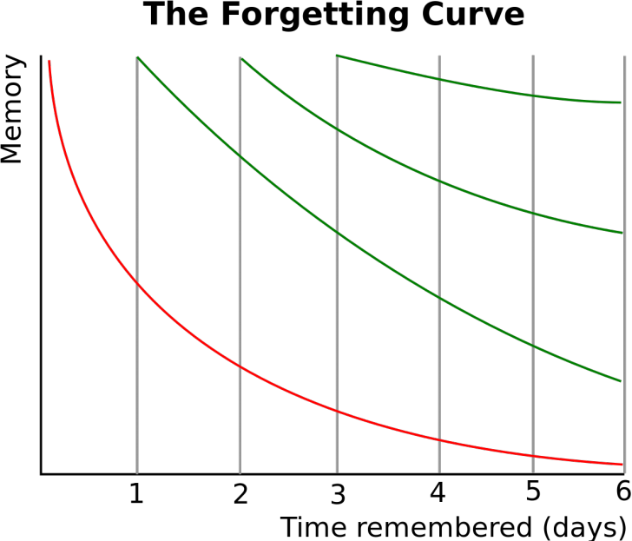

Rate of Forgetting
There are various factors that can affect the rate of forgetting.
- Meaningfulness of the information
- The way it is represented
- Physiological actors (stress, sleep, etc)

The rate of forgetting isn’t same for every one.

Increasing Memory Strength
Ebbinghaus hypothesized that difference in memory strength between individuals could be somewhat triumphed over by simple training in mnemonic techniques. Two of the methods he asserted to be among the best ways to increase strength of memory are:
- Better memory representation (e.g. with mnemonic techniques)
- Repetition based on active recall (esp. spaced repetition)

This means that students need to actively engage with information and be equipped with techniques to help them remember it. These techniques will take the form of mnemonics including visual and aural stimuli – dual coding. A key is revisiting the knowledge and strengthening the neural pathways to allow easier recall, making it so established as to become effortless. He believed that each repetition in learning leads to increase in the interval for when the next repetition is required. It was later discovered that higher original learning also leads to slower loss in memory.
What this means for us…
Making the information clear and meaningful is paramount in our teaching. Then point about being meaningful is especially interesting.
We need to actively engage with the concept of memory, explicitly teaching the best ways to remember information.
We need to be very mindful that students will not remember information over long periods of time, from year to year, term to term, and lesson to lesson, unless they constantly revisit it.
Some questions to consider…
How do you make the presentation of knowledge clear and meaningful?
How is revisiting material structured in your curriculum/ lessons?
How do you discuss memory in your lessons?
What techniques do you teach to remember information?

- Cognitive Load Theory
Memoriser – remembering and recalling key learning
Linker – Linking learning to see the bigger picture
Exposition –How clearly do I present information?
Related to memory is another theory of Cognitive science. Framing what we suspected to be true, Cognitive Load Theory reminds us that there are optimal and sub-optimal conditions of learning, many of which we can control as teachers. Taking the steps that we can, to reduce cognitive load, will improve the learning and what can be remembered. The following is an edited version of this theory from an article in Impact – the journal of the Chartered College of Teaching.
Dylan Wiliam tweeted on 26 January 2017 that he had ‘come to the conclusion Sweller’s Cognitive Load Theory is the single most important thing for teachers to know.’ This is an emphatic statement and it is important to consider the implications.
CLT, first researched by Sweller (Sweller, 1998) towards in the late 1980s, is based around the idea that our working memory – the part of our mind that processes what we are currently doing – can only deal with a limited amount of information at one time. Reif’s (Reif, 2010) description of cognitive load is extremely useful: ‘The cognitive load involved in a task is the cognitive effort (or amount of information processing) required by a person to perform this task.’ There are a number of excellent resources freely available online that explain CLT (see Paas et al. (Paas et al., 2003) for a useful overview), so we will only touch on the foundations of the theory here that will be useful for the rest of the article.
The theory identifies three different forms of cognitive load:
- Intrinsic cognitive load: the inherent difficulty of the material itself, which can be influenced by prior knowledge of the topic
- Extraneous cognitive load: the load generated by the way the material is presented and which does not aid learning
- Germane cognitive load: the elements that aid information processing and contribute to the development of ‘schemas’.
CLT suggests that if the cognitive load exceeds our processing capacity, we will struggle to complete the activity successfully. In summarising CLT, De Jong (De Jong, 2010) states that ‘cognitive load theory asserts that learning is hampered when working memory capacity is exceeded in a learning task’.
Working memory should be seen as short term and finite, whereas long-term memory can be seen as infinite. The aim should be to move knowledge to long-term memory because when a student is exposed to new material, they can draw on this previous knowledge and the cognitive load is reduced. However, if subject knowledge is incomplete, the student is unable to fall back on the long-term memory and the working memory becomes overloaded, leading to working memory failures. According to Gathercole and Alloway (Gathercole and Alloway, 2007), indications of working memory failures include:
- incomplete recall
- failing to follow instructions
- place-keeping errors
- task abandonment.
Of course, there are many other reasons for these that are not related to CLT; however, if teachers understand how this theory applies to their classroom, they can plan their lessons in a way that takes into account cognitive load.
What this means for us
A key point in this article is the following line – “Cognitive load theory asserts that learning is hampered when working memory capacity is exceeded in a learning task”
We need to be aware that our brains can become overloaded with data being inputted. We can not attend to everything that is coming our way, and we need to be able to filter information efficiently. This can be helped if we lower the cognitive loads being placed on students in their learning to free up working memory. This means sequencing information so that it can become naturalised – recalled from long term memory. We need to control the environment, the noise, the room, the class…all of those external inputs that can affect learning detrimentally. We need to become very sensitive to the manner in which we deliver the information – cutting out as much “noise” as possible, allowing the focus to be on what is important.
Some questions to consider…
How do you ensure that you minimise the intrinsic load of tasks in your curriculum/ your lessons?
How do you manage your environments to reduce extrinsic load – “minimising the noise”?
In what ways do you support students to shift knowledge from working memory to long term memory?

- Rosenshine Principles of Instruction

Orator – articulating learning through language
Questioner – Reflecting on learning
Discusser – engaging in academic discourse
Memoriser – remembering and recalling key learning
Linker – Linking learning to see the bigger picture
Responder – using feedback to improve.

Exposition –How clearly do I present information?
Moderation – How successfully do my lessons facilitate group discussion?
Questioning – How deeply does questioning probe pupil understanding?
Checking – How systematically do I check understanding and identify misconceptions?
Feed Forward – Do I make sure that insightful, timely, clear and directed feedback is acted upon and has positive impact?
In 2010 Barak Rosenshine published “Principles of Instruction”, an academic paper that sought to relate research findings into classroom practice. Its influence was global – and its application immediately recognised by teachers in multiple settings. A great place to start your own reading on this is Rosenshine’s Principles in Action by Tom Sherrington, which we have provided for all staff. What follows is an overview of his key points – (from elearning info graphics)
It is clear from the extent of the linkage shown above between Rosenshine’s Principles and our key determinants of good Teaching (The KLA 5 for staff) and Learning (The KLA 6 for pupils) how central Rosenshine’s approach needs to be in our school. What this means for us –

A guide to the basics of good practice in each lesson is priceless for teachers. Before flights, pilots engage in a pre-flight checklist to ensure optimal performance. Rosenshine’s principles allow us to do the same. They provide a framework for us to consider in the planning of our lessons, and they provide valuable reflective benchmarks in our co-planning.

Some questions to consider…

How do you implement these principles in your practice?

How explicit are you in sharing these principles with your students?

How could these principles inform co-planning within faculties and subjects?

Which of these principles do you consider to be most important with – this student? This class?
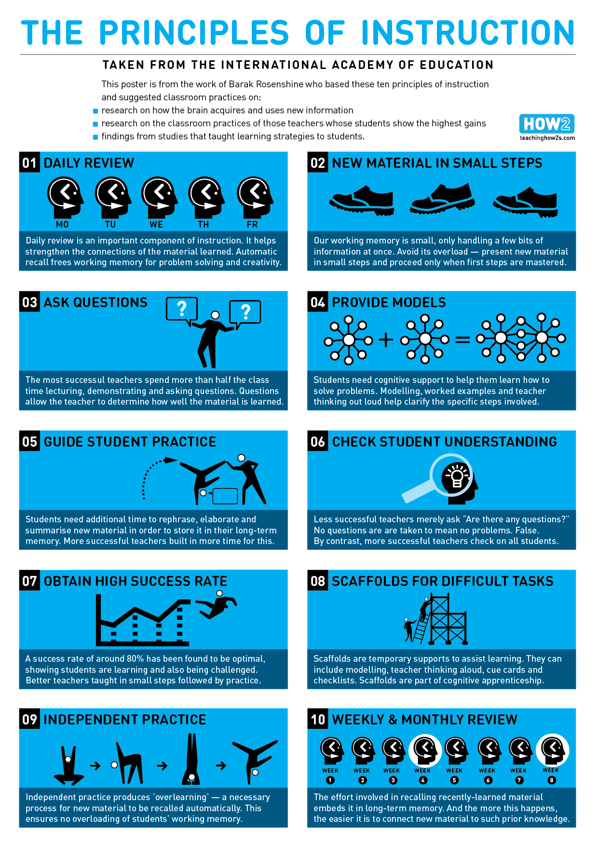

- Vocabulary – The Frayer Model

Orator – articulating learning through language
Questioner – Reflecting on learning
Discusser – engaging in academic discourse
Questioning – How deeply does questioning probe pupil understanding?
Exposition –How clearly do I present information?
Language is the gateway to knowledge. Without language, there is no ability to assimilate, manipulate, reflect and apply knowledge. This is a principle that trumps all others – it is impossible to over-exaggerate the importance of vocabulary..
The ‘Frayer model is a long-standing graphic organiser that has been deployed in classrooms with success for decades. It is a simple but effective model to help students to organise their understanding of a new academic term or complex vocabulary choice.
The traditional model is as follows:
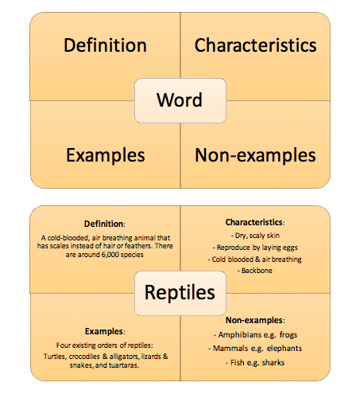
The idea here is to stop and give the language of learning its own focus. Instead of glossing over the challenging vocabulary, or giving definitions before moving on, we look at the word in more detail. The four areas we consider are;
Definition – what does the word mean?
Characteristics – what are the characteristics of the word?
Non-examples – what is the opposite/ not the word. This helps with an understanding of the word by being clear of its opposites.
Example – an example of the word in a sentence, showing its use.
This “playing” with language deepens its impact, those neural connections, and makes the vocabulary meaningful. In turn, this allows access to even deeper understanding, and reduces future cognitive loads.
What this means for us –
We should consider vocabulary as one of the most important bedrocks of learning, and rather than seeing it as extraneous or additional, should see it as central to learning. This shift will mean an investment of time where appropriate, but the “bang for buck” is enormous.
Some questions to consider…
What focus do you place on vocabulary in your lessons?
How do you explicitly teach new vocabulary, including key subject terminology?
What key words and concepts require this deeper form of vocabulary engagement?
How could Frayers be used in co-planning?
How explicit are we with students on the value of vocabulary learning?

- Vocabulary – Beck’s Pyramid

Orator – articulating learning through language
Questioner – Reflecting on learning
Discusser – engaging in academic discourse
Memoriser – remembering and recalling key learning
Linker – Linking learning to see the bigger picture
.
This model is brilliant in its simplicity and encodes something that we all know to be true. Students do not always use the correct vocabulary to express ideas – their over-dependence on simple colloquial language obscures the real depth of insight required to access higher quality learning and ultimately higher quality outcomes. Beck’s model of tiered vocabulary represents this in a pyramid infographic –
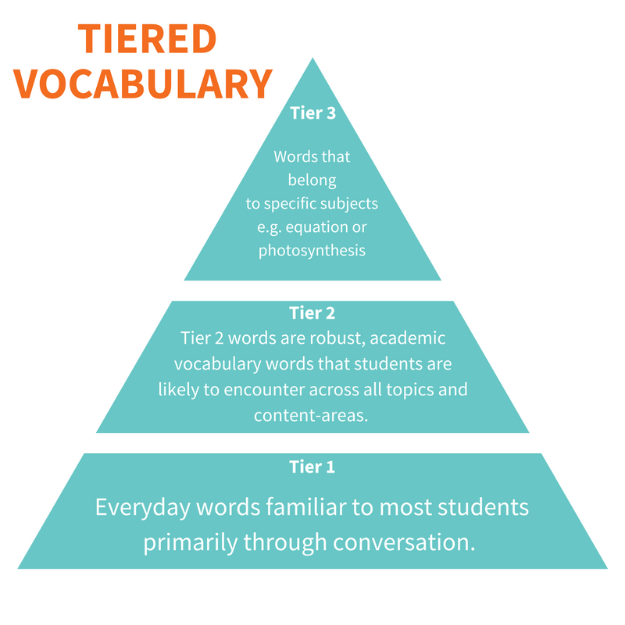
Language is divided into three distinct tiers according to its precision and academic rigour. Students are most familiar with the bottom tier – that everyday vocabulary that does the job of conveying meaning. These are words that convey everyday meaning in a workable way – often colloquial and not always precise. Beck’s model is about facilitating the second and third tiers – opening the door to a more academic discourse. Tier two words are the words that are more precise, more clear and purposeful, allowing learners to access the nuances of the concept that they are trying to master. This involves all of us in the classroom making very explicit, self- conscious decisions to use the best words possible to ensure that meaning is clear. It then follows that each subject has its own set of words which allow the deeper access. These tier three subject specific words are the gateway to full conceptual understanding.
What this means for us.
Beck tiers of vocabulary need to be applied to both speech and writing. Students and staff need to make every effort to use the right words to best describe/explain/ analyse the learning. Students should be tackled over sloppy, imprecise vocabulary and teachers should model these expectations. Academic discourse revolves around tier two and three.
Some questions to consider…
Do you model the vocabulary you expect in class?
How do you teach the tier two and three vocabulary that is required for success in your subject?
In what ways can you integrate this model into your teaching? Which topics? Which lessons?
Which students do you teach who need the most support with this?

- Vocabulary and Questioning

Orator – articulating learning through language
Questioner – Reflecting on learning
Discusser – engaging in academic discourse
Questioning – How deeply does questioning probe pupil understanding?
Checking – How systematically do I check understanding and identify misconceptions?
Feed Forward – Do I make sure that insightful, timely, clear and directed feedback is acted upon and has positive impact?
Asking questions is an essential part of what we do. However, “that’s part of the problem, because there’s evidence to suggest that teachers in the UK ask far more questions than in many high performing parts of the world, and that our questions are just not as good” (Dylan William, Geoff Barton). The reasons for this are many – perhaps the question is badly expressed, and unclear. Perhaps it is a closed question requiring a short answer that never develops understanding. Perhaps we hurry through questions, piling them up so that they become confusing, accepting the first answer and moving on. The following extract is taken from Barton’s “How to ask better questions” and provides some excellent questioning techniques.
Creating a context for better questioning
Emphasise the classroom as a place for exploring ideas, for improving our collective understanding and where making mistakes is a natural part of learning. This means giving less superficial praise for answers and exploring the content of what is said.
Use a no-hands-up approach. This depends on good discipline but can lead to a very different dynamic in the classroom. It needs deliberate flagging in the way questions are set up.
Always build in thinking time and oral rehearsal. This isn’t making questioning easier; it’s not a dilution. Rather, it’s a way of developing more thoughtful responses and making it more likely that a pupil who lacks confidence will respond because he or she has had the opportunity to rehearse an answer with a partner or small group.
To develop more extended responses, ask “why” and “how” questions and tell pupils that their answers must contain more than, say twenty words.”
What this means for us.
Excellent questions lead to excellent answers. We need to investigate and use these questioning techniques and more. Developing full responses from questions using tier two and three vocabulary will deepen learning and reinforce vocabulary. Getting students to answer in full sentences reinforces the academic discourse that they need to access.
Some questions to consider…
How good are the questions in your lessons?
To what extent are they planned?
How do you deal with the wrong answer?
How do you ensure engagement for all?
What standards of oracy do you demand?

- Reading – The Scarborough Rope.
The skill of reading is vital to the success of our students. From the earliest stumbles in reception phonics, to the comprehension of sophisticated schema, the ability to read is essential. At KLA we have a series of initiatives to support our weakest readers to supplement the work of colleagues in the classroom. And it is everyone’s job to support students with the texts that we lay before them. The Scarborough rope is a brilliantly simple visual representation of the skills required to read and learn successfully. It is the starting point for us as we learn more about how to support our students. For students to understand the texts that we present them with, they have to be consummate with these skills. On a simple level they have to be able to recognise and decode the words that they see. And then they need to be able to apply background knowledge to make sense of the text. By looking at reading in this granular way, the Scarborough rope gives us a framework to identify some of the key factors tat might be hampering comprehension in our classroom.
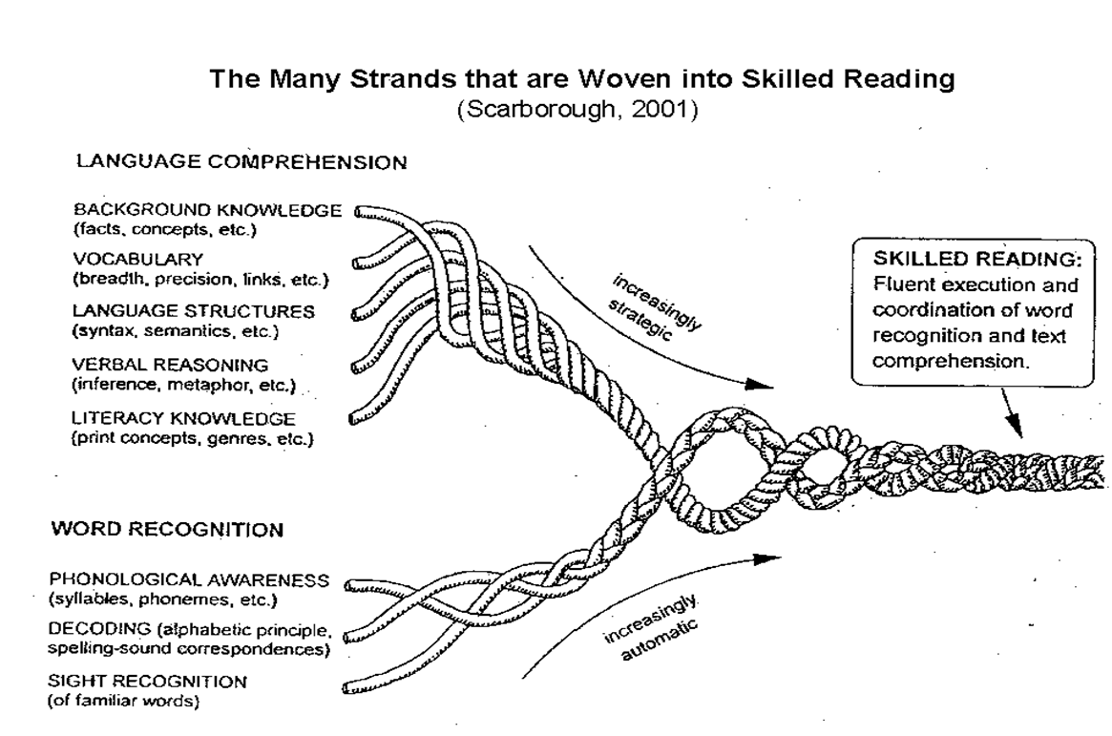
What this means to us
We need to maximise our students understanding of the texts that we present to them. We cannot reasonably do this without firstly understanding the different processes that are required in successful reading. Whilst we need to delve deeper into each of these, the Scarborough rope allows us to reflect on not only the suitability of the text that we are presenting, but also what problems we might encounter. It also provides us with an important diagnostic tool too.
Some questions to consider…
How well do you understand the process of reading in your classroom?
What problems do you encounter in reading in students’ reading?
What elements of the Scarborough rope do you think you address? What don’t you address?
How could this model inform and develop your practice?

- Reading – Rasinski Fluency Rubric

Operator – articulating learning through language
Questioner – Reflecting on learning
Discusser – engaging in academic discourse
Linker – Linking learning to see the bigger picture
Responder – using feedback to improve.

Reading is a fundamental pillar of learning, and the Scarborough rope dissects this process. Another key principle that students need to master is reading fluently. It is only through fluent reading that true comprehension can happen. Too often, text is rushed through, treated almost as an unfortunate inconvenience before the main task in a lesson. If we want the students to read carefully, and fluently, then we need to value the reading process and model our expectations.
Rasinki’s Fluency Rubric delineates the four essential skills that are required to read fluently. These are –
- Expression and volume: the varying of expression and volume to match the interpretation of the passage being read.
- Phrasing: the reading of words and clauses with appropriate pauses, with an awareness of reading mostly in clauses and sentences over individual words.
- Smoothness: any breaks or difficulty in reading are resolved with self-correction.
- Pace: an even, conversational reading rhythm.
For students to read a text independently they need to read with 95% word-reading accuracy. For students to fully comprehend they need to read fluently. As Alex Quigley, a national reading expert puts it -
“Almost every teacher, not wholly confident in the science of reading, can recognise a reader who lacks fluency. Simply sitting down with a pupil for a couple of minutes can offer enough to judge the fluency issues, judging pace, phrasing and volume, alongside words per minute…with a greater understanding of the science of reading, we needn’t be seduced by the myth of speed and we should instead prioritise the development of reading with fluency for pupils across the phases from 5 – 15 years”

What this means for us.
We need to talk explicitly about the fluency of reading, and what readers need to do to be fluent. Regardless of the text, from a long, complex passage, to a simple exam question, we need to demonstrate and emphasise fluency. Consider for a moment the reading of an exam question. One is rushed and misdirects understanding. The other is slower, careful, emphasising the lilt of the command word – and immediately deeper. We can use Rasinski’s rubric to diagnose and improve fluency and comprehenision.

Some questions to consider…
How fluent is the reading in your classroom? Yours? Students?
How could you integrate Rasinski’s rubric into your lesson?
Which children do you teach who struggle with this? How can you support them?

